**Proposal on Expense Tracker**



**Submitted by:**

Name: **Aman Shrestha**

NCC ID: 176090

Batch: 23

Table of Contents

**Chapter 1 Introduction** 3

**1.1.** **Introduction to your system** 3

**1.2.** **Background to the system** 3

**1.2.1** **Problem statement** 3

**1.3.** **Justification of the project** 3

**1.4.** **Overview of the proposed system Chapter** 3

**Chapter 2: Scope** 4

**3.1.** **Aims of the project** 4

**3.2.** **Objective of the project** 4

**3.3.** **Features included in it** 5

**3.4.** **Overview of the scope** 5

**Chapter 3: Development methodology** 6

**3.1.** **Methodology to be used** 6

**3.2.** **Design pattern** 6

**3.3.** **System architecture** 8

**Chapter 4: Scheduling** 9

**4.1** **WBS (Work Breakdown Structure)** 9

**4.2** **Milestones** 10

**4.3** **Gantt chart** 11

**Chapter 5: Risk Management** 13

**Chapter 6: Configuration Management** 15

**Chapter 7: Conclusion** 16

**Reference and Bibliography** 16

# **Chapter 1 Introduction**

## **Introduction to your system**

The word "budget" has the power to make a lot of people panic, as it has a reputation for being both tedious and challenging. It really is important to keep track of how you are spending your money. It is the first step to understanding how you are managing your money, and to taking control of your finances. It’s one of the most important tools in building a successful financial future, because it helps you get the most out of your money. Tracking your expenses can help you stop feeling like you have little to show for your hard work.

Expense tracker is an app to track your all the expenses bared by you & manage your personal finance.

## **Background to the system**

Normally, people manage their budget by simply memorizing it or writing it on a notebook. Each person’s foundation is different, just as each financial situation is different. It may seem like a simple work, but increased transaction led towards more complexity.

### **Problem statement**

These type of traditional practices usually led to miscalculation and caused several problems. This made people monotonous due to repetitive tasks of recording transaction.

## **Justification of the project**

The rise of technology has made great impact on our lives. Nowadays people want tasks to be quick and easy. Similarly, to solve the task of tracking expenses more effortlessly I have come up with this idea of an expense tracker. Individuals can use this app to manage their costs according to their budget.

## **Overview of the proposed system Chapter**

The app is basically designed to replace the traditional methods of tracking expenses and making this task more easy and effective. It traces where the money goes as well as from where money comes from. Users can limit & plan accordingly. A feature rich tracking application with numerous powerful tools like, Income/Expense, Bills, Accounts, Reports etc.

# **Chapter 2: Scope**

## **Aims of the project**

The main aim of this project is to track expenses generally to create financial awareness. Few aims of the projects are as follows:

1. Finance awareness

The real reason to track expenses is to create financial awareness. People can organize their budget as their needs leading to maximum satisfaction from their limited income.

1. Stabilizing the budget

The expense should not exceed beyond the expected budget. For this reason, the user can make expenses as per their assumption.

1. Identify spending issues

Ignoring small expenses lean towards high impact on the budget. By tracking these types of expenditures user are made alert about their current situation.

## **Objective of the project**

The main objectives of the project are to as follows:

1. Remind people to stick to their budget
2. Provide information of their current budget
3. Alert user about their expenses
4. Provide details regarding the nature of income
5. Obtain maximum utility through properly mobilized limited budget

## **Features included in it**

The main features of the projects are:

1. Notification

Notification can remind user about the expenses made and also gives idea about the current situation of the budget.

1. Automation

Repetitive type of works can be monotonous and boring. To reduce these sort of tasks automation plays a vital role. Record keeping of daily transactions or expenses through automatic features can help reduced tedious work.

1. Reports

The app will be able to show different expenses (e.g. foods, clothing, education, etc.) made during a particular period of time (e.g. daily, weekly, monthly, yearly, etc.).

1. Graphical representations

Huge amount of data can be difficult to analyze in a single glance. Graphs can help user get better understanding about the complex data.

## **Overview of the scope**

There are many limitations in this project but with many scopes as well. Our aim is to improve on this limitation periodically and maximize the benefits and scope the project will provide. These should be implemented with objectives in mind without going off-topic.

# **Chapter 3: Development methodology**

## **Methodology to be used**

I have chosen Waterfall model for the development of this project. Waterfall Model referred to a linear-sequential life cycle model. It is very simple to understand and use. This methodology is suitable for this project as it is small and has less chance of requirement changes. The process are split into smaller steps and are complete one by one. Only after a step is completed the next step is started.

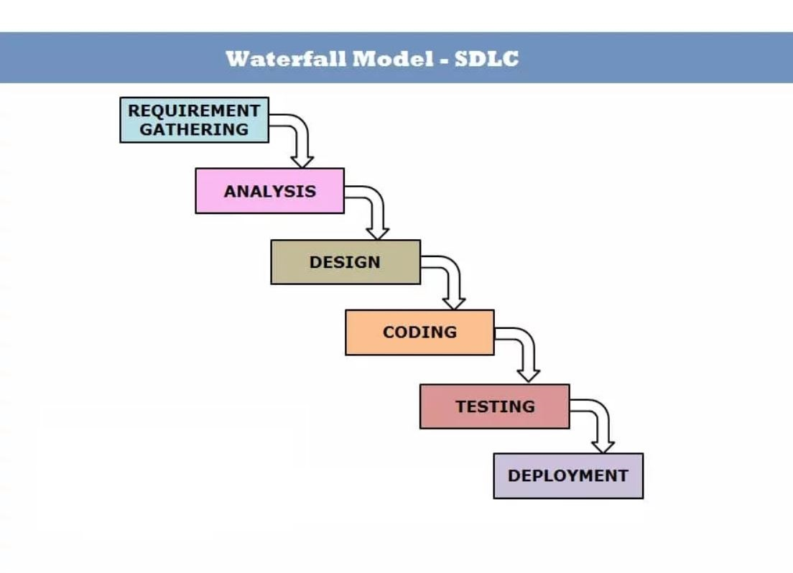

Figure 1: Waterfall Methodology

## **Design pattern**

I have used MVP design pattern to overcome the problems of embed functionality to the context.

MVP is an architectural pattern that separates an application into three main logical components i.e.

* View: A passive interface that displays data and routes user actions to the Presenter.
* Model: A layer that holds business logic, controls how data is created, stored, and modified.
* Controller: A middle man which retrieves data from Model and show it in the View. It also process user action forwarded to it by the View.

Each of these components are responsible for achieving development aspects of an application. This has become widely used industry-standard software development framework that create scalable and extensible projects.

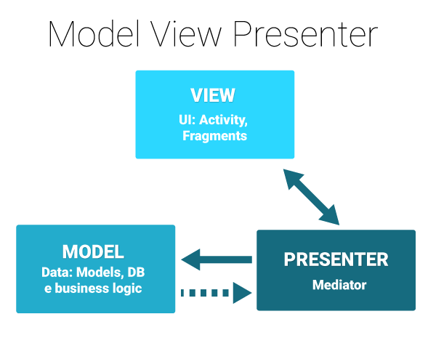

Figure 2: MVP Design Pattern

## **System architecture**

Systems Architecture is a response to the conceptual and practical difficulties of the description and the design of complex systems. Architecture serves as a blueprint for a system. It provides an abstraction to manage the system complexity and establish a communication and coordination mechanism among components.

A three-tier architecture is a client-server architecture in which the functional process logic, data access, computer data storage and user interface are developed and maintained as independent modules on separate platforms. Three-tier architecture is a software design pattern and a well-established software architecture.

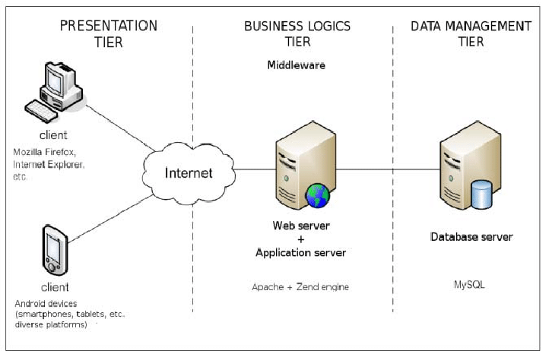

Figure : 3 tier Architecture

# **Chapter 4: Scheduling**

## **WBS (Work Breakdown Structure)**

WBS stands for Work Breakdown Structure. Work breakdown structure visually defines the scope into manageable chunks that a project team can understand, as each level of the work breakdown structure provides further definition and detail.

Figure : WBS Diagram

**Proposal**

Introduction

Scope and Objectives

Development Methodology

Scheduling

Configuration Management

**Analysis**

Requirement Analysis

Use Cases

**Implementation**

**Design**

Behavioral Modal

Database Design

Interface Design

Coding

**Testing**

Unit Testing

White Box Testing

Validation Testing

**Documentation**

Final Documentation

**Expense Tracker**

User Manual

Black Box Testing

Database Construction

Structural Modal

Risk Management

Requirement Gathering

## **Milestones**

|  |  |  |
| --- | --- | --- |
| **Task Name** | **No of days** | **Date (Start date- End date)** |
| |  | | --- | | **Proposal** | | 1. Introduction | | 1. Scope and Objectives | | 1. Development Methodology | | 1. Scheduling | | 1. Risk Management | | 1. Configuration Management | | **15 days**  2 days  2 days  4 days  1 day  3 days  3 days | **6/17/2019 - 7/1/2019**  6/17/2019 – 6/18/2019  6/19/2019 – 6/20/2019  6/21/2019 – 6/24/2019  6/25/2019 – 6/25/2019  6/26/2019 – 6/28/2019  6/29/2019 – 7/1/2019 |
| |  | | --- | | **Analysis** | | 1. Requirement Gathering | | 1. Requirement Analysis | | 1. Use Cases | | **28 days**  10 days  12 days  6 days | **7/2/2019 – 7/29/2019**  7/2/2019 – 7/11/2019  7/12/2019 – 7/23/2019  7/24/2019 – 7/29/2019 |
| |  | | --- | | **Design** | | 1. Structural Modal | | 1. Behavioral Modal | | 1. Database Design | | 1. Interface Design | | **31 days**  9 days  9 days  5 days  8 days | **7/30/2019 – 8/29/2019**  7/30/2019 – 8/7/2019  8/8/2019 – 8/16/2019  8/17/2019 – 8/21/2019  8/22/2019 – 8/29/2019 |
| |  | | --- | | **Implementation** | | 1. Database Construction | | 1. Coding | | **22 days**  5 days  17 days | **8/30/2019 – 9/20/2019**  8/30/2019 – 9/3/2019  9/4/2019 – 9/20/2019 |
| |  | | --- | | **Testing** | | 1. Unit Testing | | 1. Black Box Testing | | 1. White Box Testing | | 1. Validation Testing | | **10 days**  3 days  2 days  2 days  4 days | **9/21/2019 – 9/30/2019**  9/21/2019 – 9/23/2019  9/24/2019 – 9/25/2019  9/26/2019 – 9/27/2019  9/27/2019 – 9/30/2019 |
| |  | | --- | | **Documentation** | | 1. User Manual | | 1. Final Documentation | | **12 days**  4 days  8 days | **10/1/2019 – 10/12/2019**  10/1/2019 – 10/4/2019  10/5/2019 – 10/12/2019 |
| **Total** | **119 days** | **6/17/2019 – 10/12/2019** |

## **Gantt chart**

Gantt chart is a chart in which a series of horizontal lines shows the amount of work done or production completed in certain periods of time in relation to the amount planned for those periods. To produce Gantt chart for this project I have used Project Libre.

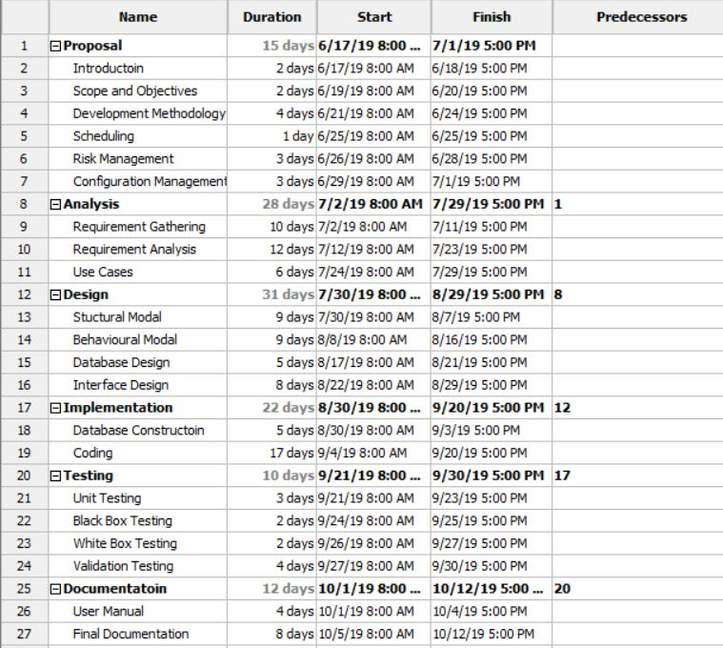

Figure 5: Gantt Chart Table

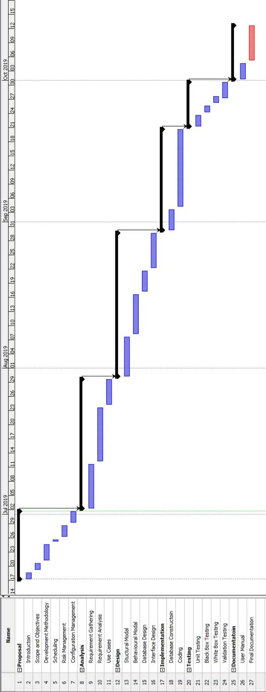

Figure 6: Gantt chart

# **Chapter 5: Risk Management**

Risk management is the process of identifying, assessing and controlling threats to an organization's capital and earnings. These threats, or risks, could stem from a wide variety of sources, including financial uncertainty, legal liabilities, strategic management errors, accidents and natural disasters. IT security threats and data-related risks, and the risk management strategies to alleviate them, have become a top priority for digitized companies. As a result, a risk management plan increasingly includes companies' processes for identifying and controlling threats to its digital assets, including proprietary corporate data, a customer's personally identifiable information and intellectual property.

All risk management plans follow the same steps that combine to make up the overall risk management process:

1. Risk identification

The company identifies and defines potential risks that may negatively influence a specific company process or project.

1. Risk analysis

Once specific types of risk are identified, the company then determines the odds of it occurring, as well as its consequences. The goal of the analysis is to further understand each specific instance of risk, and how it could influence the company's projects and objectives.

1. Risk assessment and evaluation

The risk is then further evaluated after determining the risk's overall likelihood of occurrence combined with its overall consequence. The company can then make decisions on whether the risk is acceptable and whether the company is willing to take it on based on its risk appetite.

1. Risk mitigation

During this step, companies assess their highest-ranked risks and develop a plan to alleviate them using specific risk controls. These plans include risk mitigation processes, risk prevention tactics and contingency plans in the event the risk comes to fruition.

1. Risk monitoring

Part of the mitigation plan includes following up on both the risks and the overall plan to continuously monitor and track new and existing risks. The overall risk management process should also be reviewed and updated accordingly.

**Likelihood table:**

|  |  |
| --- | --- |
| **Likelihood** | **Value** |
| Low | 1 |
| Medium | 2 |
| High | 3 |

**Consequences table:**

|  |  |
| --- | --- |
| **Consequence** | **Value** |
| Very low | 1 |
| Low | 2 |
| Medium | 3 |
| High | 4 |
| Very high | 5 |

**Risk Management table:**

|  |  |  |  |  |  |
| --- | --- | --- | --- | --- | --- |
| **ID** | **Risk** | **Likelihood** | **Consequence** | **Impact** | **Action** |
| 1 | Scope not well defined | 2 | 4 | 8 | Analysis of requirement must be done properly in the beginning of the project. |
| 2 | Virus thread | 2 | 3 | 6 | Daily scan and installation of antivirus. |
| 3 | Hard disk crash | 1 | 5 | 5 | Frequent data backup. |
| 4 | Shortage of resources | 2 | 5 | 10 | The resources required for the project should be identified and gathered. |
| 5 | Lack of management | 3 | 3 | 9 | The project should be well managed and have backup plans |
| 6 | Failure to follow methodology | 1 | 5 | 5 | Methodology should be choose considering all the aspects. |

# **Chapter 6: Configuration Management**

Configuration management is collective figure of activities, tools, processes and methods project practitioners can use to be able to manage items during the project life cycle.

For this I have used GitHub which manages files and folder that are related to the project in systematic way so that it would be easy to access the file any time.

The link to access the project is:

<https://github.com/aman0010/CP-Project>

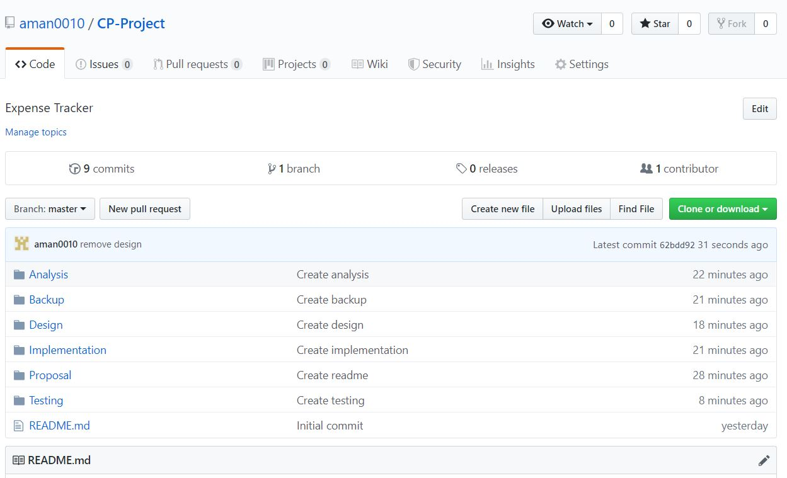

Figure 7: Screenshot of GitHub

# **Chapter 7: Conclusion**

This project of expenses tracking would help track expenditures made by the user. Users can not only track and know about their expenses, they can also input about their different sources of income. The prime aim of this project is to build a user friendly interface and help them determine their expenses as per the determined budget.

# **Reference and Bibliography**

<https://blog.hubspot.com/marketing/waterfall-methodology>

<https://android.jlelse.eu/architecture-patterns-in-android-abf99f2b6f70>

<https://searchcompliance.techtarget.com/definition/risk-management>